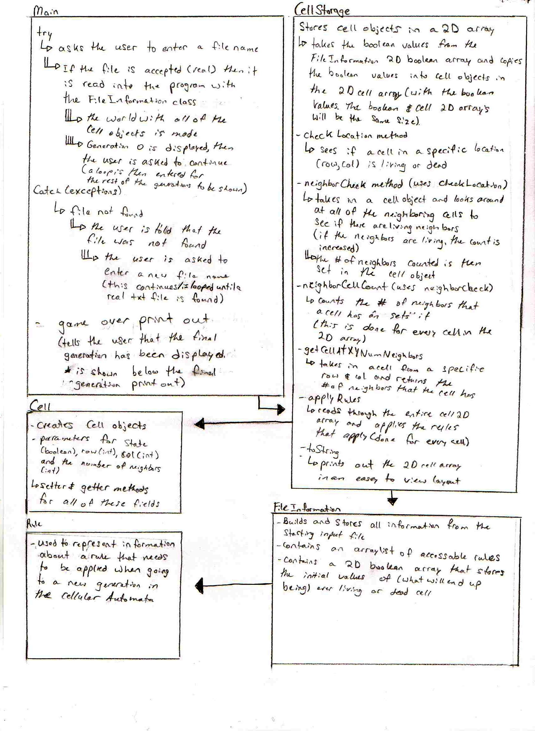**COMP 2503 Assignment 1 – Cellular Automata Design**